**Credit Card Java Application**

Credit Card App is a console application which is developed using Java implementing various Design Patterns. This Application lets the user to provide the Credit Card records for which the application determines the type of the Credit Card.

The user can provide the records in various files including CSV, JSON, XML. The application reads a record from the file, verifies that the credit card number is a possible account number, and creates an instance of the appropriate credit card class. The files contain credit card information. It contains field for credit card number, expiration date, and the name of the card holder.

The design patterns implemented are:

1. Strategy Pattern.
2. Iterator Pattern.
3. Factory Method Pattern.

The Class Diagrams for these design patterns are as follows:

1. Strategy Pattern

[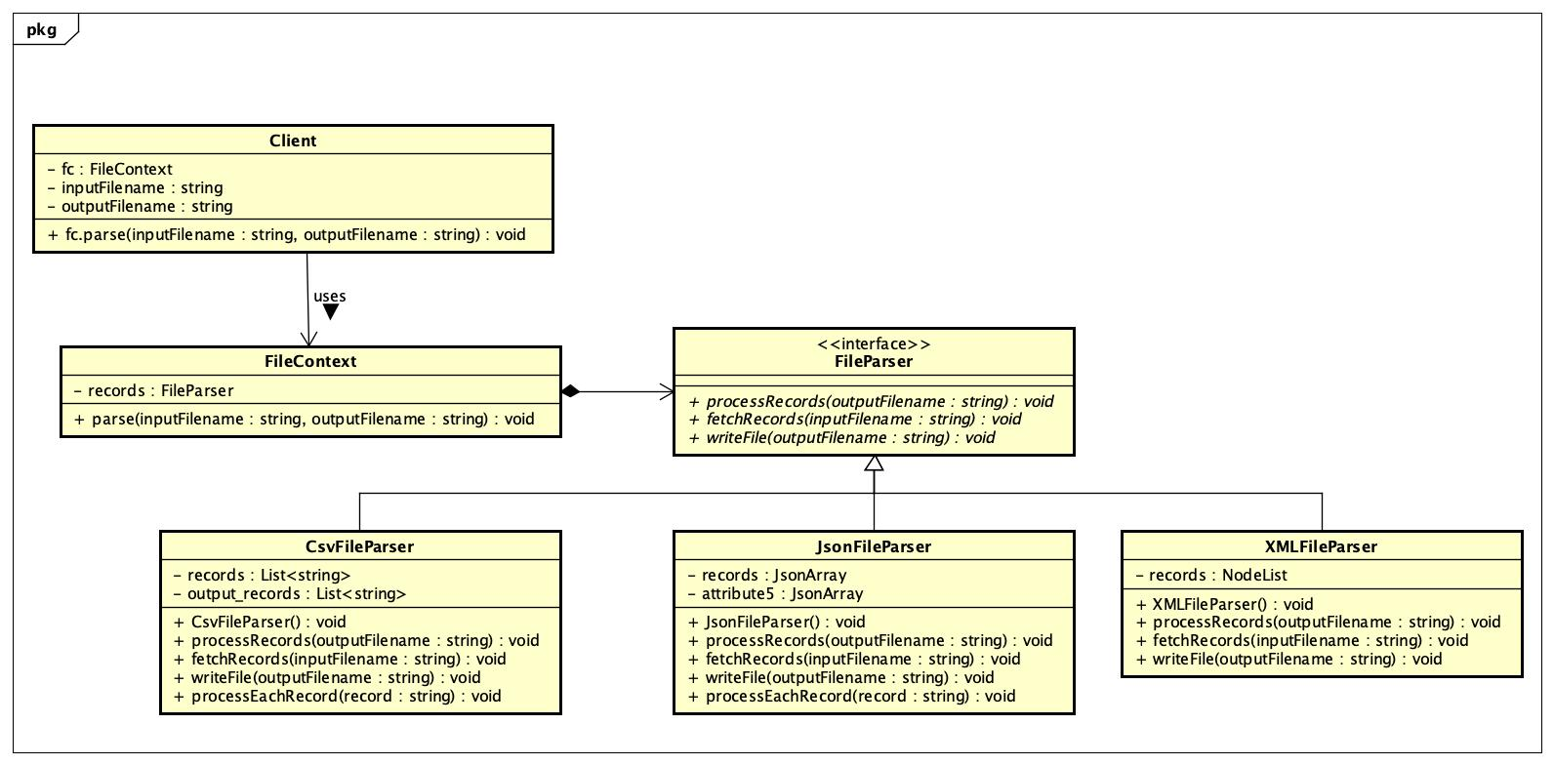](https://github.com/RonakMehta21/CreditCard/blob/master/images/StrategyPattern.jpg)

1. Iterator Pattern

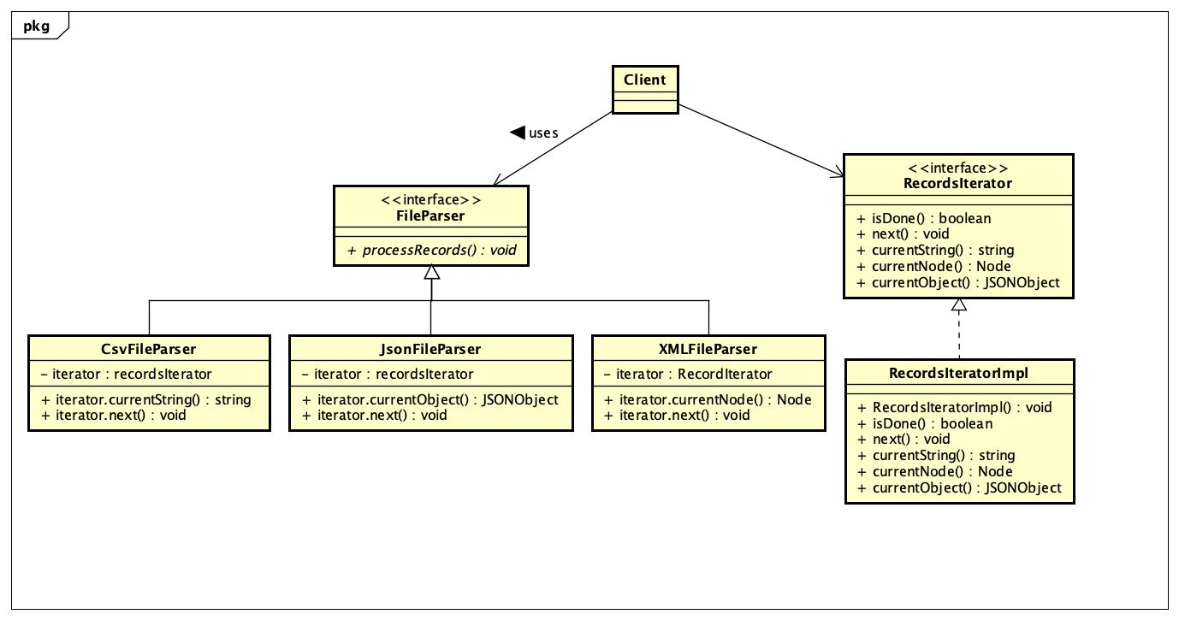

1. Factory Method Pattern

[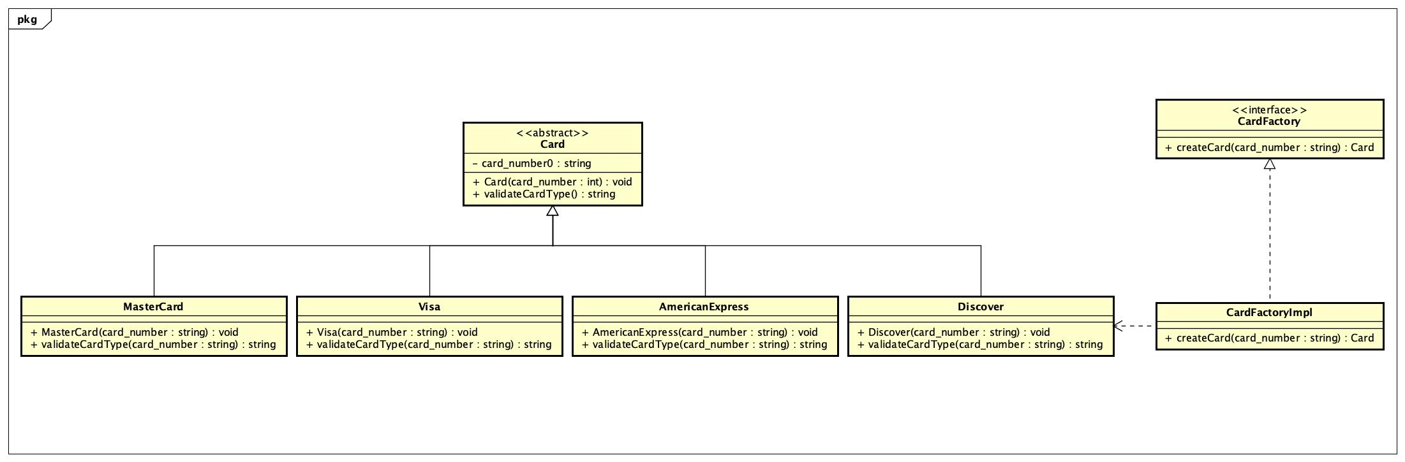](https://github.com/RonakMehta21/CreditCard/blob/master/images/FactoryMethodPattern.jpg)